Calling all Pickleball Players!

Pickleball has been growing quickly at The Villages. Our club membership has grown to over 100 people, and we’re always looking for more people to play this easy to learn game. Currently, Pickleball can be played on courts 5 & 6, using the blue tape lines laid down on the court already. Sign up at the Tennis Shack; currently Pickleball players can sign up 5 days in advance for time slots 10:30 and later. Paddles and balls are available for use in our storage unit (located in the back corner of Court 6). Please make sure to wear shoes with non-marking soles on the bottom. Members are eligible for a discount when purchasing equipment; discount cards are available by contacting Steve Williams at steveandkumi@gmail.com

Every Wednesday in October, Mike & Julie Walias are going to be at courts 5 & 6 at 1:30 PM to work with new and intermediate players! These are a great opportunity for those interested to learn both how to play and also meet potential partners at the same playing level. You’ll be amazed how quickly the game can be learned, as well as how much fun it is. We maintain an online calendar were users can sign up, but it’s much easier to meet people face to face to set up initial groups.

If you aren’t sure of all the rules, here is some basic information to get you started! The court itself is the size of a badminton court, but the net is low to the ground like Tennis. The blue tape outlines the shape of the court, enabling both Tennis and Pickleball to be played on the same court. The result is three “boxes” on each side of the net. One is closer to the net, and called the “Kitchen” or “Non-Volley Zone”, the two further back are the service areas.
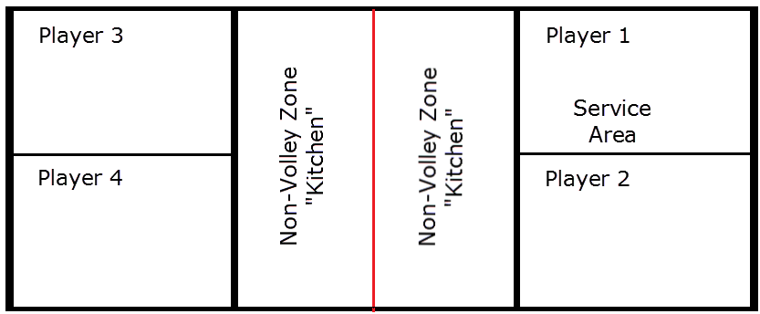

Here at the Villages, almost all games played are doubles, involving four players. The rules are a little different than other court games, but the basics are summarized below. The diagram of the court shows how players are set up to play.
Start of Game – Player one serves the ball. Serving is done underhand, and the ball must contact the paddle below the players’ waist. The server stands behind their back service line, and the ball must bounce in player fours service area. If the ball lands in the “kitchen”, that players turn immediately ends.

Return of Ball – When player four returns the ball, they can hit it to either side of the opposite court, but must first allow it to bounce once. Before player one or two can hit it back, they must let the ball bounce once as well. After the two initial volleys, the ball is no longer required to bounce before being hit.

Continuation of game – After the initial two hits, players have the option of hitting the ball on the fly (volleying) or letting it bounce once. The point continues until one side misses – either hitting the ball into the net or landing outside the court.

The Kitchen – Players can never step into the “Kitchen” area and volley a ball. The only time a player can step in the kitchen is if the ball bounces first – and then they should step out. This is a common error to make, so be careful!

Stay tuned for additional articles, which will explain how to play and give hints for strategy!

