Calling all Pickleball Players!

Wednesdays at 1:30 PM is drop in Pickleball. Mike and Julie Walias are available to instruct and assist forming groups. This is a great opportunity both to learn and meet potential partners.

Last week covered the basics of game play. Future articles in this series will focus on different areas!

Today we discuss how to score a game. The first team to reach eleven wins, and must win by two points. The server continues to serve until they fail to score a point. The only oddity is the first serve of the game. After deciding which team should server first, the player to the right (Player 1) serves first.

Player one serves until they lose a point, when the service will move to their opponents.

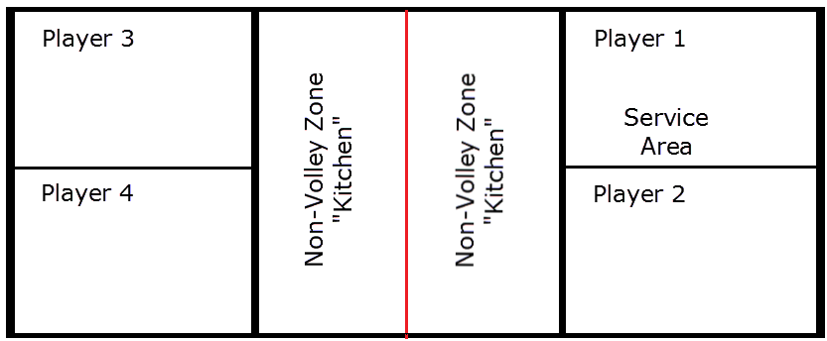

It’s important to call the score, including the server number prior to each serve. That helps the players to keep the server and the score straight. To minimize the advantage of being the first team to serve in a game, only one player gets a service turn on the first turn of the game. Call the score in the order of server’s score, receiver’s score, and then the server number. When starting a game, the score is always Zero-Zero-Start. This signifies neither team has a point, and the game at the start.

Once the first server has completed their turn, the receiving team goes. Whoever is on the right side of the court serves for that turn only. The next time that team gets the serve back; it may be the other player on the right, who will be the first server, and will be server number “One”. Beginning players often mistakenly assume that the player keeps the same server number throughout the game. Just remember service number only applies to that turn.

For example if the score of the serving team is 3 and the score of the receiving team is 6, and the first server for that side is serving, the score would be announced as 3-6-1. If no point is scored, the serve moves to the second player, and the score is now called as 3-6-2.

Play continues until one side scores 11 points, although they must win by at least two points. Next week, we’ll focus more on the play itself, going into more depth on the rules of play.

